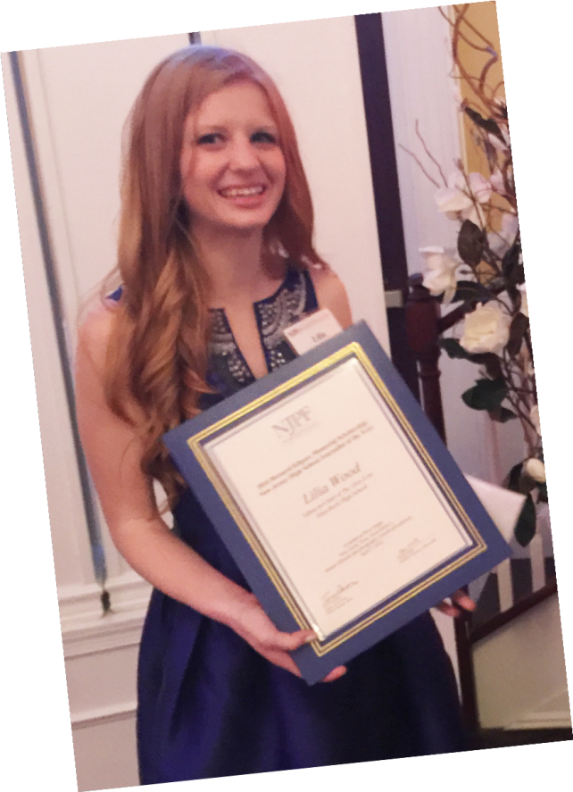
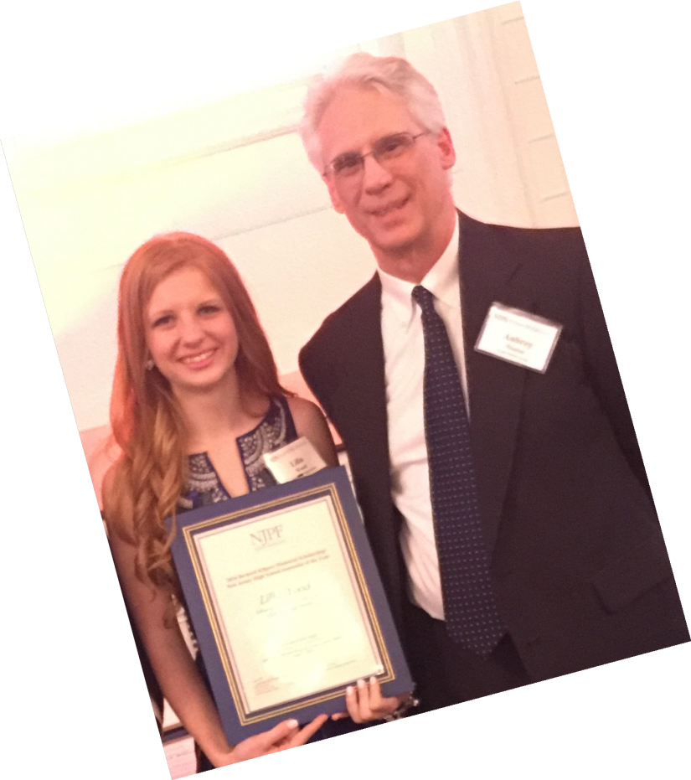
This could be you!
...with a $5,000 college scholarship in journalism

2021
Bernard Kilgore Memorial Scholarship

and

New Jersey High School Journalist of the Year Award

APPLICATION

Open to high school seniors who are graduating this year from a New Jersey school.

Winner of the Kilgore Scholarship also is named the NJ High School Journalist of the Year

DEADLINE EXTENDED:
Application must emailed by February 8, 2021, parbitell@njpa.org

NEW JERSEY PRESS FOUNDATION
P.O. Box 358
Titusville, NJ 08560
(609) 406-0600 ext. 14 • www.njpressfoundation.org

A Scholarship toward Your Future
Considering a career in media? If so, then getting a journalism degree is a smart investment in your future. The Bernard Kilgore Memorial Scholarship can help make college more affordable.

About this Award

The Bernard Kilgore Memorial Scholarship will be awarded following a statewide competition sponsored by the New Jersey Press Foundation and the Garden State Scholastic Press Association.

The scholarship – valued at $5,000 – will be awarded by New Jersey Press Foundation, which administers the Bernard Kilgore Memorial Scholarship Fund. The scholarship recipient is selected by a panel of New Jersey newspaper editors.

The recipient also is named GSSPA’s New Jersey
High School Journalist of the Year and is entered in
a competition for the National High School Journalist of the Year, operated by the Journalism Education Association.

The Bernard Kilgore Scholarship is possible because of gifts to the New Jersey Press Foundation from the Kilgore family and friends, The Princeton Packet, and the Dow Jones Foundation.
Eligibility

The competition is open to New Jersey residents attending New Jersey high schools. Applicants are nominated by teachers at schools that are members of the Garden State Scholastic Press Association. Editors of newspapers that are members of the
New Jersey Press Association also may nominate students.

If the scholarship recipient attends a high school that doesn’t employ a GSSPA member, the New Jersey Press Foundation will pay the $15 membership fee for that school for the year the scholarship is awarded.

Qualifications

To be eligible to receive the Bernard Kilgore Memorial Scholarship and be named New Jersey High School Journalist of the Year, you must:

• Graduate this year from a New Jersey high school

• Plan to study journalism/media studies in college and to pursue a career in the media

• Have at GPA of at least a 3.0 on a 4.0 scale

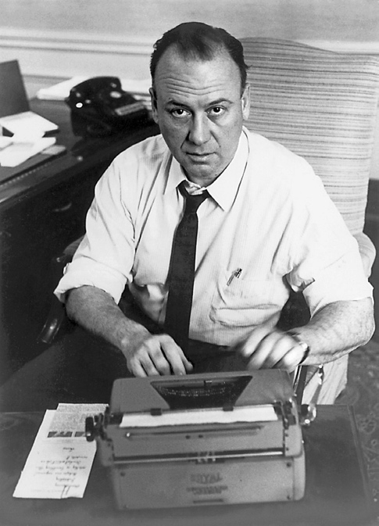
• Have participated in high school journalism for at least two years

Who was Bernard Kilgore?

Bernard Kilgore was the dominant figure at The Wall Street Journal and its parent corporation, Dow Jones and Co., Inc., for more than a quarter century.
He was 59 years old when he died in 1967. By then, the Journal had grown from a small financial newspaper into the nation’s only national daily newspaper. In 2000, TJRF Group named him the Business Journalist of the Century.
Kilgore believed that the newspaper business needed to identify and encourage talented writers and editors in order to remain strong and profitable.

Preparing Your Portfolio

• ALL APPLICATIONS AND MATERIALS WILL BE EMAILED TO: PARBITELL@NJPA.ORG

• Entry material must not exceed 46 pages, including the one-page application form. All letters and transcripts must be included as part of the 46 pages.

• Send at least one sample of relevant spreads from your yearbook (not the entire book), so the judges can see the context of your work. Do not send CDs, DVDs, etc.

• Photocopies of letters, clippings, photos and art are acceptable; however, an original print of photograph should accompany entries based on published pictures. Your personal photo is in addition to the 46-page maximum.

• Here are some ideas to help you get started on the self-analytical evaluation: How do you feel about journalism? How did you get started in journalism? What have you had to go through to achieve? What have you contributed to journalism? What are your journalism plans for the future? The evaluation should be long enough for the judges to reach a decision about your creative qualifications and short enough not to be redundant.

• Samples of your work should be carefully selected. Provide the judges with a good cross-section of your best work rather than everything you have produced. Date, name of publication and relevance (see list below) should be on the page with each sample. Samples must be readable photocopies of published work.

• Include samples showing one or more of the following characteristics. They should be grouped according to what they represent, and these relevance groupings should be labeled.

a. Skilled and creative use of media content – writing, production, photography, etc.
b. Inquiring mind and investigative persistence resulting in in-depth study or studies of issues important to the local high school audience, high school students in general, and/or society.
c. Courageous and responsible handling of sensitive issues – local or societal – despite any threat or imposture of censorship.
d. Variety of journalistic experiences, each handled in a quality manner – newspaper, yearbook, broadcast, photography, Web design, other design work, community and other out-of-school journalistic work, etc.

Portfolio checklist

The applicant must include the following:
The official entry form
A self-analytical evaluation of your “journalistic life,” using your most creative form.

An action photo of you doing something journalistic – interviewing someone, designing a page, taking a photo or talking to your staff.

Proof that you have participated in high school journalism for at least two years. Official high school transcript.
Three or four letters of recommendation from your adviser, other teachers who know your leadership and journalistic abilities, and practitioners with whom you have worked. A letter from the principal is desirable, but not absolutely necessary.

Samples of your work carefully selected to show the quality and diversity of your reporting, writing, photography, design, etc.

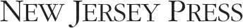
2021 Bernard Kilgore Memorial Scholarship
Application deadline — February 8, 2021

PERSONAL INFORMATION

Student’s Name

Home Address

City

State

Zip

E-mail Address

Home Phone

Parent/Guardian Name_________________________________________________________________________________________
How long have you been in journalism:__________________________________
Publication Names Positions From To

Has any of your work been cited by the media? Yes – please use a separate sheet to explain No

Do you plan to enroll in a journalism degree program? Yes No

What areas of journalism are of potential career interest?

List the colleges you are considering, in order of preference. If you have decided which college you will attend, list only that one.

Accepted Accepted Accepted Accepted

HOMETOWN NEWSPAPER

Name of Newspaper

Address

City

State

Zip

HIGH SCHOOL INFORMATION

Name of School

Address

City

State

Zip

Adviser’s Name

Advisor’s Email Address

Adviser’s Phone

Entries must be emailed by:
February 8 to:
parbitell@njpa.org

